**1. Import the dataset and do usual exploratory analysis steps like checking the structure & characteristics of the dataset.**

1) Data type of all columns in the “customers” table.

SELECT column_name, DATA_TYPE FROM `ecommerce-393918.target.INFORMATION_SCHEMA.COLUMNS`

WHERE table_name = 'customers';

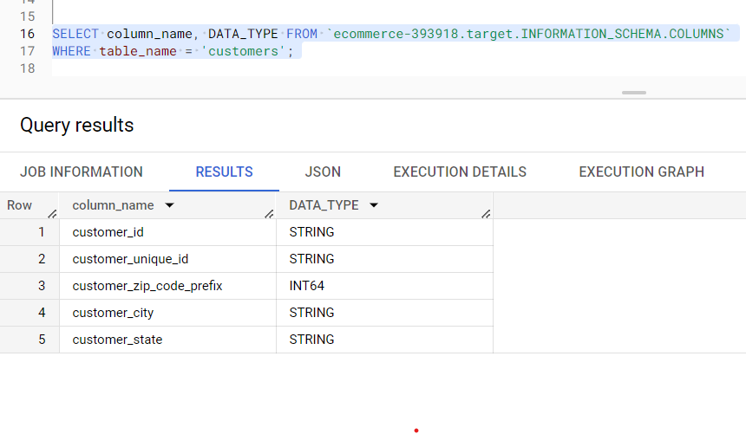

2) Get the time range between which the orders were placed.

select min(order_purchase_timestamp) as first_order,

max(order_purchase_timestamp) as last_order ,

max(order_purchase_timestamp)- min(order_purchase_timestamp) as time_range

from target.orders

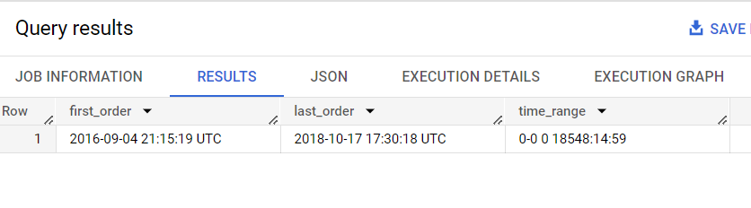

3) Count the number of Cities and States in our dataset.

select count(distinct customer_city) as city, count(distinct customer_state)  as state from `target.customers`;

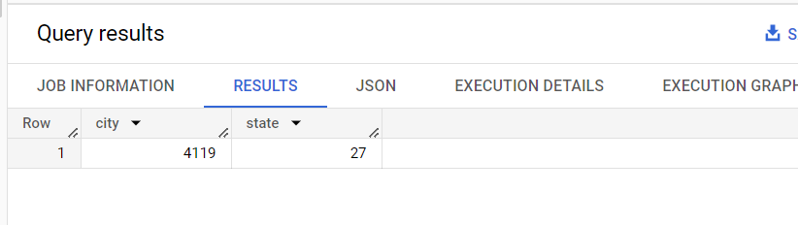

**2)**

**1)** Is there a growing trend in the no. of orders placed over the past years?

SELECT

  EXTRACT(YEAR FROM order_purchase_timestamp) AS order_year,

  EXTRACT(MONTH FROM order_purchase_timestamp) AS order_month,

  COUNT(*) AS order_count

FROM target.orders

GROUP BY

  order_year,

  order_month

ORDER BY

  order_year,

  order_month;

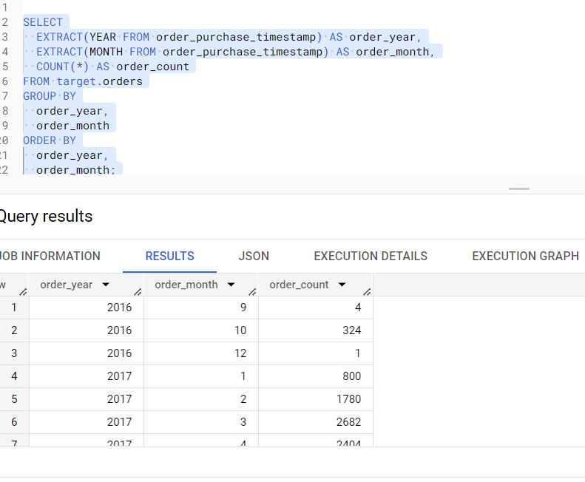

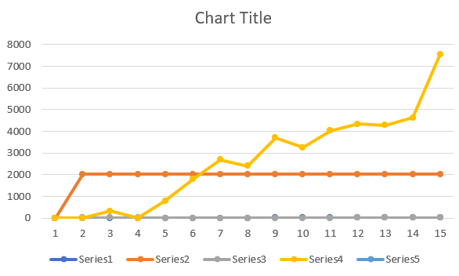

**Analysis -** There is a gradual increase in the count of order in comparison with 2016 data and regular trends of increase of counts from 2016 to 2017 to, there is sudden downward trend in 2018 in the month of September and October but this downfall gradually started from April, 2018 by decrease in count by some hundreds.

2) Can we see some kind of monthly seasonality in terms of the no. of orders being placed?

SELECT

  EXTRACT(MONTH FROM order_purchase_timestamp) AS order_month,

  COUNT(*) AS order_count

FROM `target.orders`

group by order_month

ORDER BY order_month;

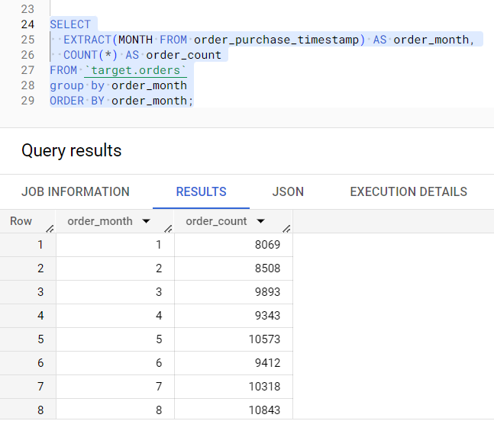

**Analysis -** Yes, there is a monthly seasonality while ordering the orders. There are maximum orders placed in the month of May, July and August.

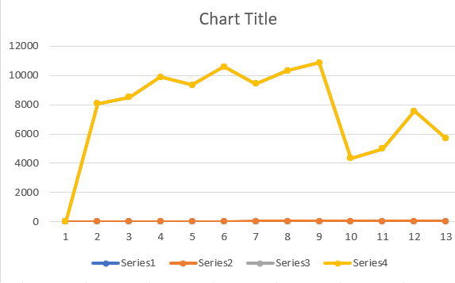

3) During what time of the day, do the Brazilian customers mostly place their orders? (Dawn, Morning, Afternoon or Night) ● 0-6 hrs : Dawn ● 7-12 hrs : Mornings ● 13-18 hrs : Afternoon ● 19-23 hrs : Night

SELECT

CASE

        WHEN EXTRACT(HOUR FROM order_purchase_timestamp) BETWEEN 0 AND 6 THEN 'Dawn'

        WHEN EXTRACT(HOUR FROM order_purchase_timestamp) BETWEEN 7 AND 12 THEN 'Morning'

        WHEN EXTRACT(HOUR FROM order_purchase_timestamp) BETWEEN 13 AND 18 THEN 'Afternoon'

        WHEN EXTRACT(HOUR FROM order_purchase_timestamp) BETWEEN 19 AND 23 THEN 'Night'

    END AS time_interval,

    COUNT(*) AS order_count

FROM target.orders

GROUP BY

    time_interval

ORDER BY

    order_count DESC;

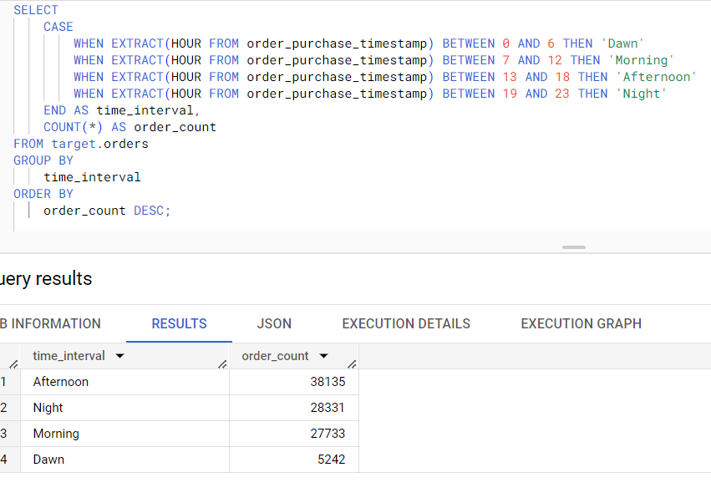

**Analysis -** There are maximum orders placed in the afternoon hour from 13 to 18.

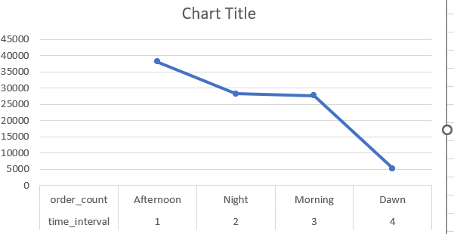

3) Evolution of E-commerce orders in the Brazil region.

1) Get the month on month no. of orders placed in each state.

SELECT

    customer_state,

    EXTRACT(month FROM order_purchase_timestamp) AS mth,

    COUNT(order_id) AS num_orders

FROM target.customers join target.orders

on orders.customer_id=customers.customer_id

GROUP BY customer_state, mth

ORDER BY customer_state, mth;

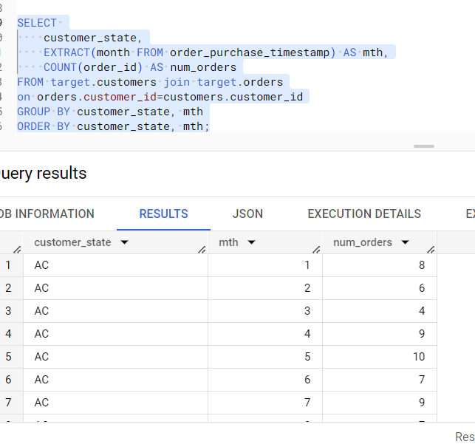

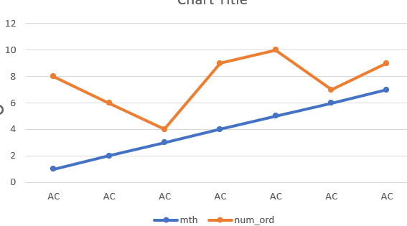

2) How are the customers distributed across all the states?

SELECT customer_state, COUNT(DISTINCT orders.customer_id) AS unique_customers

FROM target.orders

JOIN target.customers

ON orders.customer_id = customers.customer_id

GROUP BY customer_state;

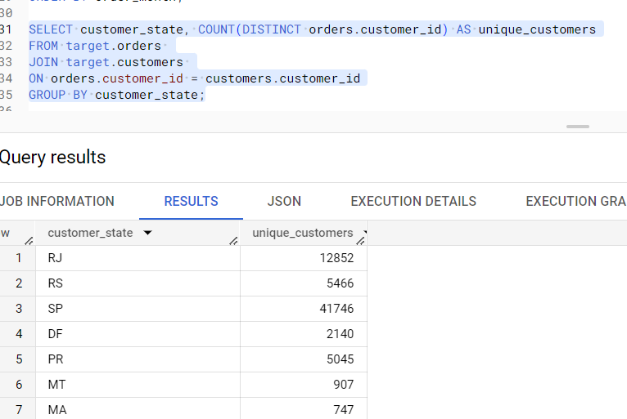

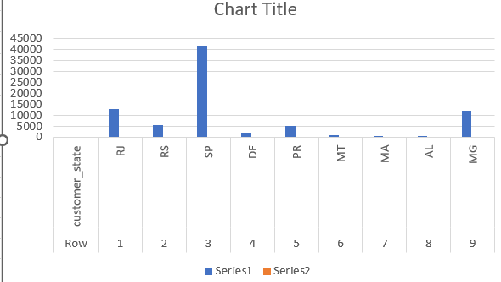

**Impact on Economy: Analyze the money movement by e-commerce by looking at order prices, freight and others.**

1. Get the % increase in the cost of orders from year 2017 to 2018 (include months between Jan to Aug only)

SELECT ((sum(

          Case

          when extract(year from order_purchase_timestamp)=2018 and extract(month from order_purchase_timestamp)<=8

          then payment_value

          else 0 end)- sum(

          Case

          when extract(year from order_purchase_timestamp)=2017

          then payment_value

          else 0 end))/sum(

          Case

          when extract(year from order_purchase_timestamp)=2017

          then payment_value

          else 0 end))*100 as Percentage_increase

          from Target.orders join Target.Payments on

          orders.order_id=payments.order_id

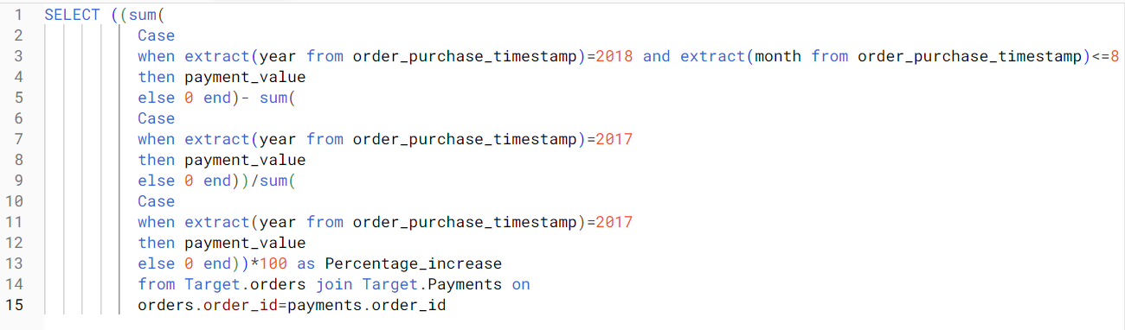

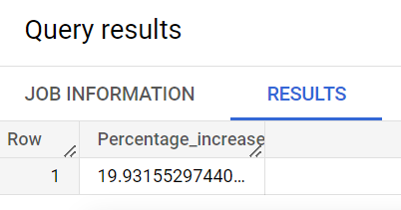

ANALYSIS : There has been an increase of ~20 % in cost in year 2018 compared to year 2017

2.Calculate the Total & Average value of order price for each state.

SELECT customer_state,round(sum(payment_value),2)as total_order_price,

round(AVG(payment_value),2) as avg_order_price from Target.customers join Target.orders on

customers.customer_id =orders.customer_id

join Target.Payments

on orders.order_id=payments.order_id

GROUP BY customer_state;

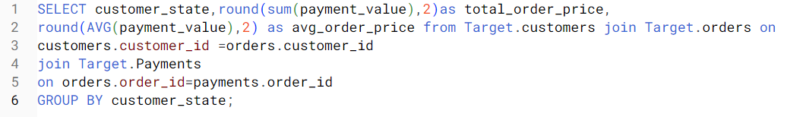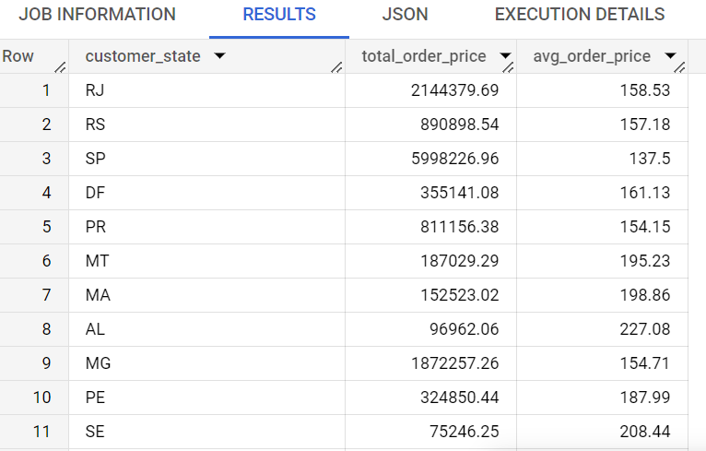

3.Calculate the Total & Average value of order freight for each state.

select customer_state,

sum(freight_value)as total_freight_value, AVG(freight_value) as avg_freight_value

from Target.customers join Target.orders on customers.customer_id=orders.customer_id

 join Target.order_items on

 orders.order_id=order_items.order_id

 group by customer_state;

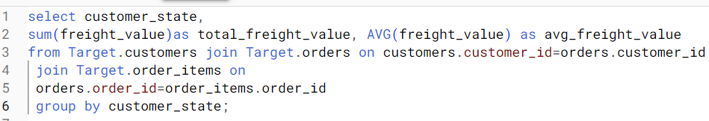

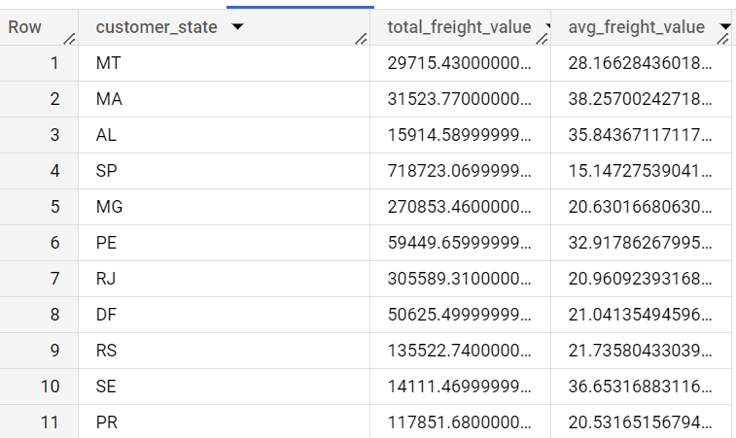

**Analysis based on sales, freight and delivery time.**

1. Find the no. of days taken to deliver each order from the order’s purchase date as delivery time.  
   Also, calculate the difference (in days) between the estimated & actual delivery date of an order.

SELECT order_id,date_diff(order_delivered_customer_date,order_purchase_timestamp,day) as time_to_deliver,

date_diff(order_estimated_delivery_date,order_delivered_customer_date,day) as diff_estimated_delivery

from

Target.orders



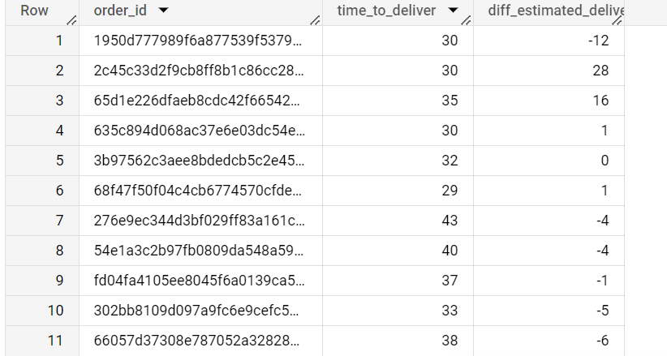

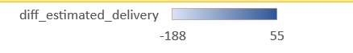

ANALYSIS : As per the data Delay in orders was maximum 188 days where as in case of fast delivery it reached only 55 days prior to estimated delivery date

2.Find out the top 5 states with the highest & lowest average freight value.

SELECT customer_state,

AVG(freight_value)as avg_freight_value

from

Target.customers

join Target.orders on customers.customer_id=orders.customer_id join Target.order_items

ON orders.order_id = order_items.order_id

group by customer_state

order by avg_freight_value desc

limit 5

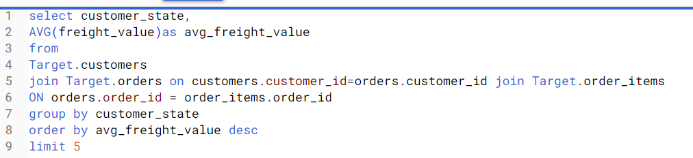

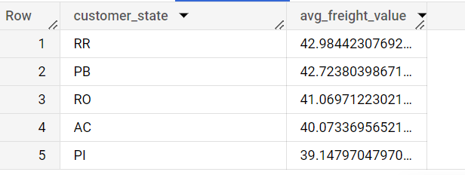

SELECT customer_state,

AVG(freight_value)as avg_freight_value

from

Target.customers

join Target.orders on customers.customer_id=orders.customer_id join Target.order_items

ON orders.order_id = order_items.order_id

group by customer_state

order by avg_freight_value asc

limit 5

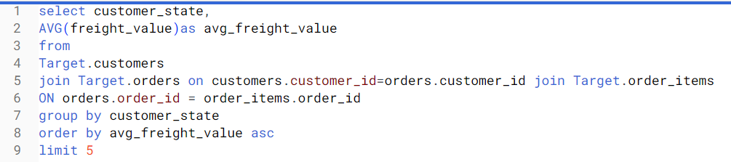

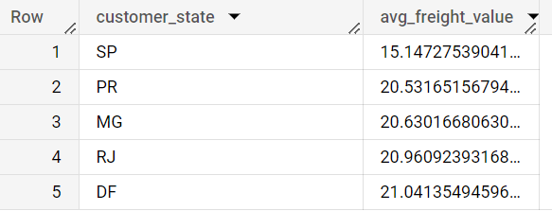

3.Find out the top 5 states with the highest & lowest average delivery time.

SELECT customer_state,

AVG(DATE_DIFF(order_delivered_customer_date,order_purchase_timestamp,day)) as Avg_Delivery_Time

from Target.orders join Target.customers

on orders.customer_id=customers.customer_id

group by customer_state

order by Avg_Delivery_Time asc

limit 5

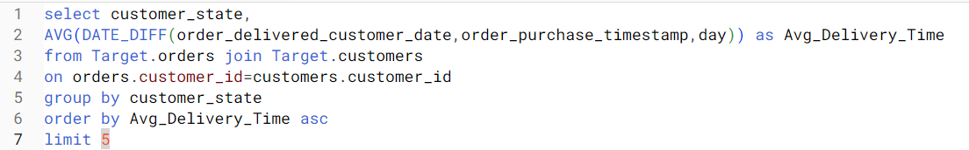

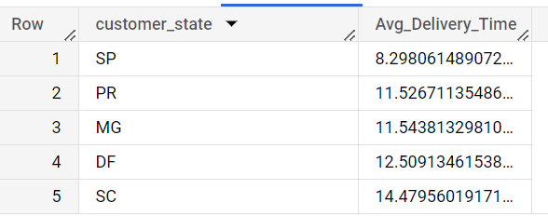

SELECT customer_state,AVG(DATE_DIFF(order_estimated_delivery_date,order_delivered_customer_date,day)) as Avg_Delivery_time

from

Target.customers join Target.orders

on customers.customer_id=orders.customer_id

group by customer_state

order by Avg_Delivery_time desc

limit 5

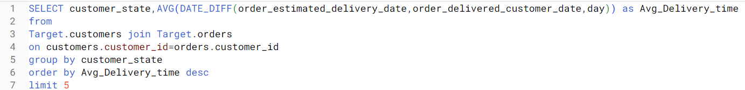

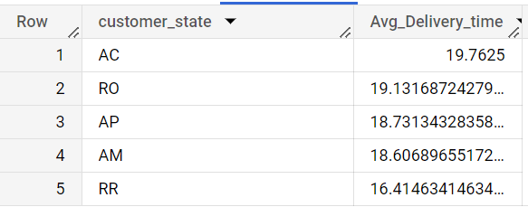

4.Find out the top 5 states where the order delivery is really fast as compared to the estimated date of delivery.

SELECT customer_state,

AVG(DATE_DIFF(order_delivered_customer_date,order_purchase_timestamp,day)) as Avg_Delivery_Time

from Target.orders join Target.customers

on orders.customer_id=customers.customer_id

group by customer_state

order by Avg_Delivery_Time desc

limit 5

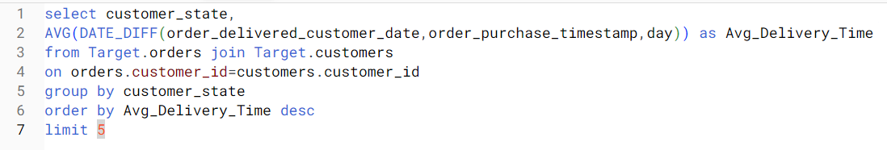

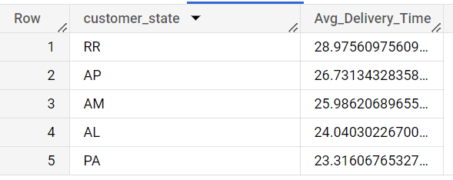

**Analysis based on the payments:**

1.Find the month on month no. of orders placed using different payment types.

select Extract(month from order_purchase_timestamp) as payment_month,

payment_type,count(p.order_id)as Num_orders

from Target.orders join Target.Payments p on

orders.order_id=p.order_id

group by payment_month,payment_type

order by payment_month

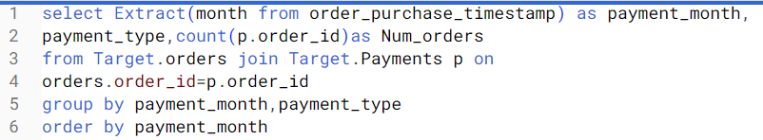

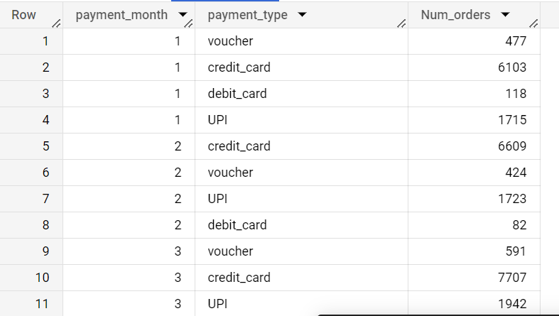

ANALYSIS : With the given data we can find that maximum purchases are made by credit cars followed by UPI , Voucher and Debit Card respectively.

2.Find the no. of orders placed on the basis of the payment installments that have been paid.

select count(order_id) as Num_orders,payment_installments

from Target.Payments

group by payment_installments

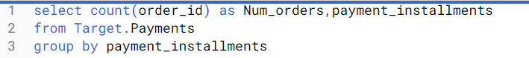

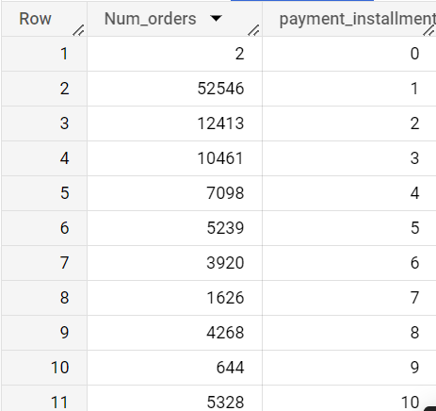

ANALYSIS: As we can observe orders with maximum payment installment are 1,2 & 3 which tells most of the orders were placed in last month.